Name:  Teacher : | ____________________________________  ______________________ |  | Date:_________
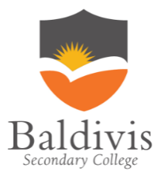 | Year 12 Essentials  /  Measurement  Full working out MUST be shown to get full marks for each question.
Total Time: | 30 minutes
Weighting: | 5%
Equipment: | Pen, pencil, ruler, scientific calculator.

Question 1 8 marks (2, 2, 2, 2)

] Find the area of these shapes.
a] b]
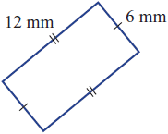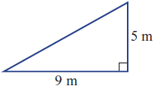

c] d]
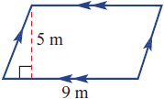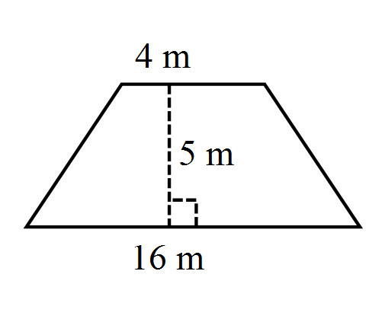

Question 2 6 marks (3, 3, 3)

Find the circumference and area for this circle. Answer to 2 decimal places.
[4 marks]
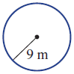

Circumference Area

Question 3 6 Marks (3,3)

Find the area of these sectors and composite shapes
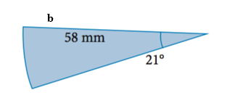
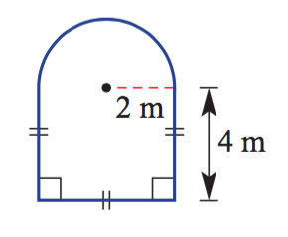
a

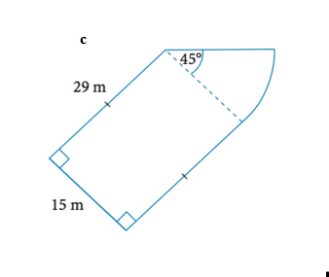

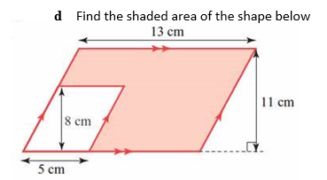

Question 4 7 Marks (2, 2, 3)

Find the surface area of each of the following.
- b]
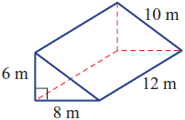

c) Find the surface area of each of the following, rounding your answer to 2 decimal places.

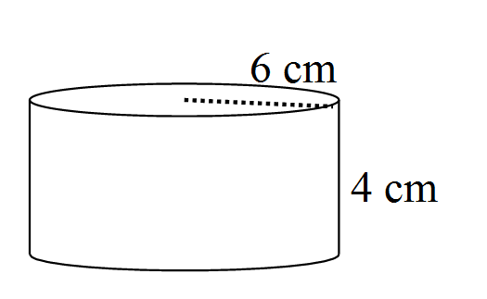

Question 5 8 Marks (2, 2, 2, 2)

Find the surface area of the following composite shape.

a)
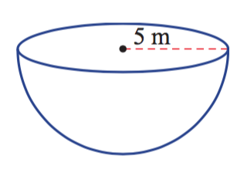

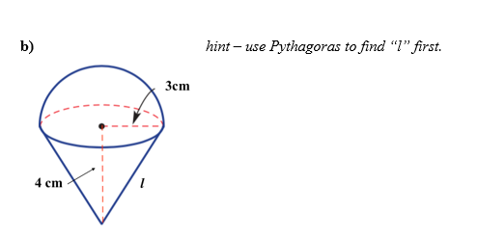

Question 6 8 Marks (2, 2, 2, 2)

Find the volume of the following.
- b)

c) Find the volume of the following cylinder, rounding your answer to 2 decimal places.

Question 7 6 Marks (3,3)

a) What is the volume of a cylindrical water tank with a radius 12m and height 8m? Round your answer to 2 decimal places.

b) Find the area needed to paint the outside of a cube with side lengths of 3cm

Question 8 2 Marks (2)

A rectangular prism has a volume of 48m³. It has a width of 2m and a length of 6m. What must its height be?

Question 9 2 Marks (2)

A cylinder has a volume of 339.29cm³ . It has a radius of 6cm. Find the height, to the nearest centimeter

Question 10 2 Marks (2)

- A wooden chest is made using a half-cylinder lid which is placed on top of a rectangular prism [as shown in the picture]. The chest has a length of 80cm, and the semi-circle has a diameter of 60cm. The height of the rectangular prism is 40cm. Find the total surface area for the chest, leaving your answer in exact form. [5 marks]
